Contents

Buffers 2

PTx.2% (1L) 2

PTwH (1L) 2

Permeabilizing buffer (50mL) 2

Secondary antibodies 2

Sample Collection 2

Embed brain 3

Immunolabeling 4

Clearing tissue 5

Tissue check 5

Troubleshooting 5

Antibodies tested 6

Primaries: 6

Secondaries: 6

Light Sheet Imaging 6

Mount to sample holder 6

Schedule LaVision Ultramicroscope at Microscopy Core with Nikos & Sijie 6

Quantification 6

References 7

|  |  |
| --- | --- |
| Tissue | Estimated completion time  (sack to image) |
| hemisphere brain (Klingberg) | 21 days |
|  |  |

# Buffers

### PTx.2% (1L)

* 100mL PBS 10X (900mL H2O)
* 2mL Tween20 (iDISCO uses tritonX)

### PTwH (1L)

* 100mL PBS 10X
* 2mL Tween-20
* **1mL of 10mg/mL Heparin stock solution**

### Permeabilizing buffer (50mL)

* 42mL PTx.2%
* 3mL of Goat Serum
* **5mL of DMSO**
* **0.02% Sodium azide (0.01 g to 50mL, or 0.1g to 500mL)**
* **raise to 1% Tween20 (add 0.4mL)**

# Secondary antibodies

Do not use chemical dyes, use ALEXA dyes or fluorescent proteins only (communication with Klingberg)

# Sample Collection

1. Anesthetize the mouse.

2. Perfuse with 10mL PBS.

3. Perfuse with 10mL 4%PFA/PBS.

4. Dissect the brain/organ and trim to the appropriate size.

5. Fix in 1xPBS/4%PFA at 4°C, 2 days with rocking.

6. Wash in PBS on rock: RT 1 hr x 3times.

# Embed brain

1. make 1% agarose in distilled H2O (0.25g 25mL H2O for two brains)
2. Embed brain in 1% agarose.
3. Trim agarose to make a cube (~2mm extending from each surface).
4. Make desired cut (e.g. sagittal midline).
5. Place on opposing sagittal face to ensure flat imaging surface
6. Wash in PBS on rock

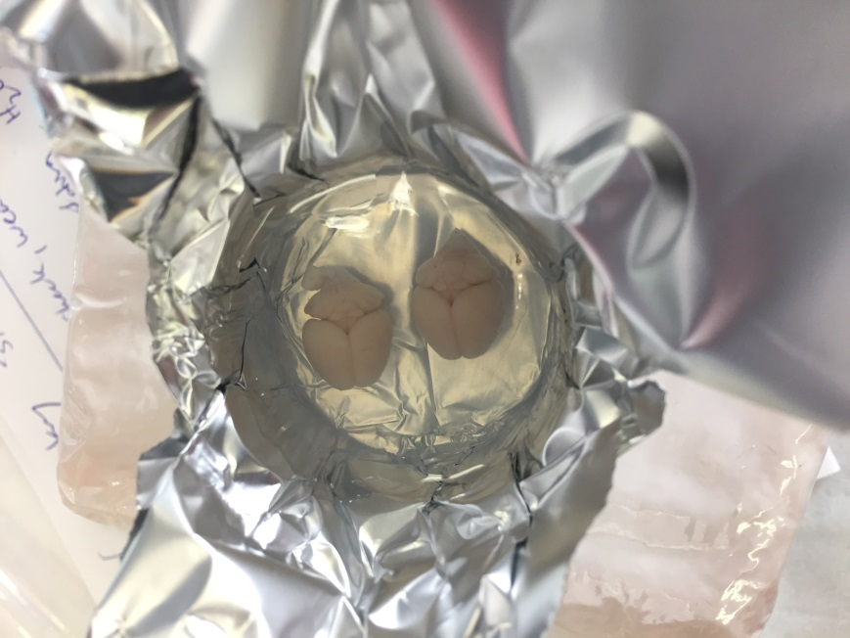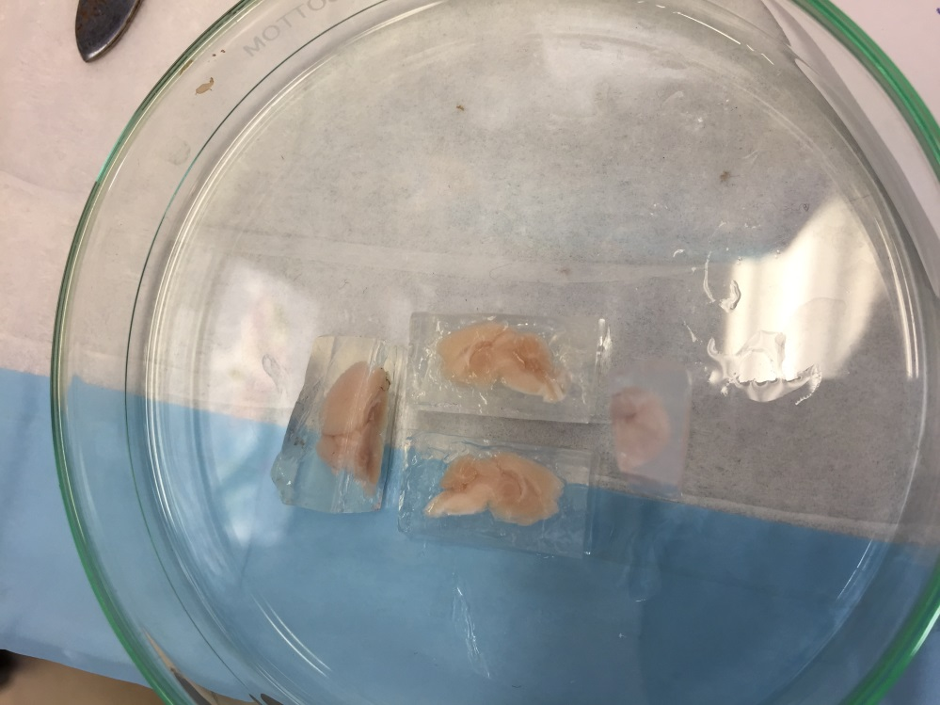

# Immunolabeling

After fixation, wash and embedding:

|  |  |  |  |  |  |  |
| --- | --- | --- | --- | --- | --- | --- |
| Tissue | Bleach 3% H2O2 in PBS1 | Block/Perm soln | 1° antibody, in PTwH/5% DMSO/3% Goat Serum | Wash sample | 2nd antibody, in PTwH/3% Goat Serum | Wash sample |
| hemisphere brain (Klingberg) | O/N rock, wash PTx.2% @ RT | 2 days rock @ 37°C | 7 days on rock @ 37°C | wash PTwH 5x 1hr each on rock @ 37°C (ok to leave O/N) | 7 days on rock @ 37°C | wash PTwH 5x 1hr each on rock @ 37°C then at least 2 days in fresh PTwH on rock @ 37°C |
| hemisphere brain (iDISCO+) |  | 2 days | 7 days |  | 2 days |  |

1. Bleach in fresh 3%H2O2 in PBS (1 volume 30% H2O2 to 5 volumes PBS).
2. For each vial, make to 6 mL total volume.
3. Heat to 37°C using electric blanket (until we can afford an incubator).

Nutating rocker (<https://www.fishersci.com/shop/products/nutating-mixer-fixed-speed120v/88861041>):

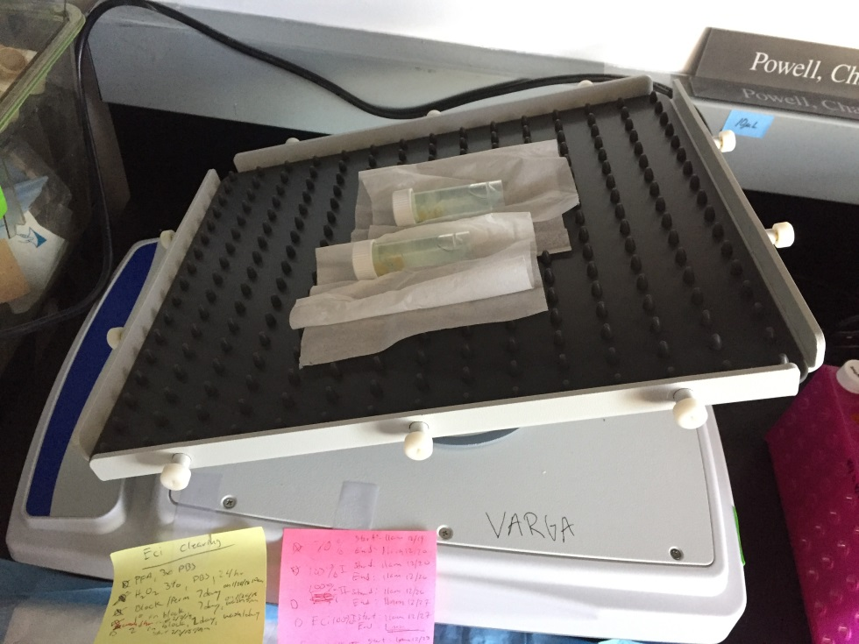

From Blocking step on, use light shield/thermal electric blanket and thermometer.

# Clearing tissue

After immunolableing:

|  |  |  |  |  |  |
| --- | --- | --- | --- | --- | --- |
| Tissue | 40% EtOH + 2% Tween (pH 9) | 60% EtOH + 2% Tween (pH 9) | 80% EtOH + 2% Tween (pH 9) | 3x 100% EtOH + 2% Tween (not pH adjusted) | 2x 100% ECi |
| Whole Brain (Klingberg) | 1hr then change to fresh for RT on rock O/N | 1hr then change to fresh for RT on rock O/N | 1hr then change to fresh for RT on rock O/N | 24hr 2x @ RT | 4hr then O/N each @ RT |
| Whole Brain (iDISCO+) |  |  |  |  |  |

Eg. Make 6mL/vial 🡪 9.6mL EtOH + 2.4mL Tween

# Tissue check

How clear does it look?

Attempt #1 on 121817 🡪 Yellowish

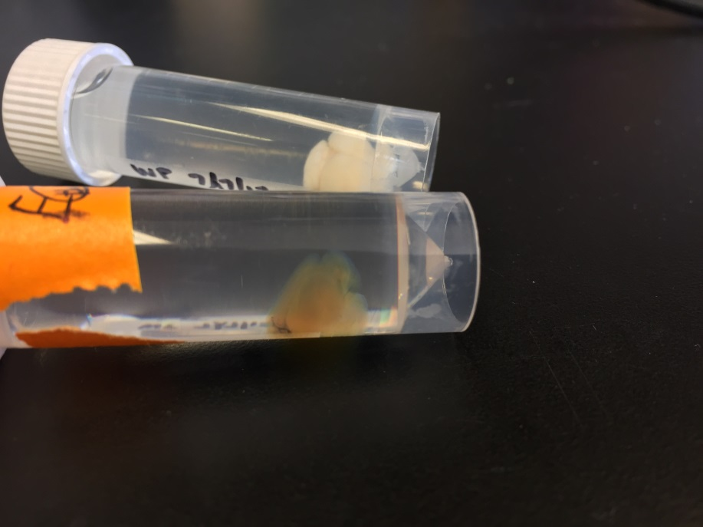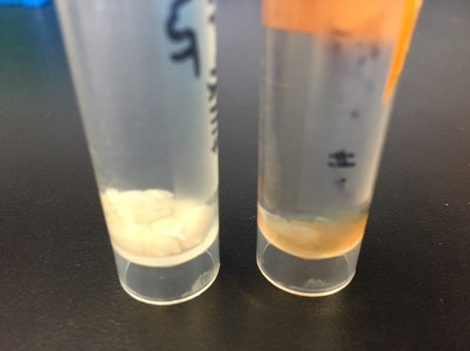

Attempt #2 on 2/12/18 🡪 bleach + minimize air in tubes (6.5mL) 🡪 1:100 TH and 1:100 a647 🡪 too much

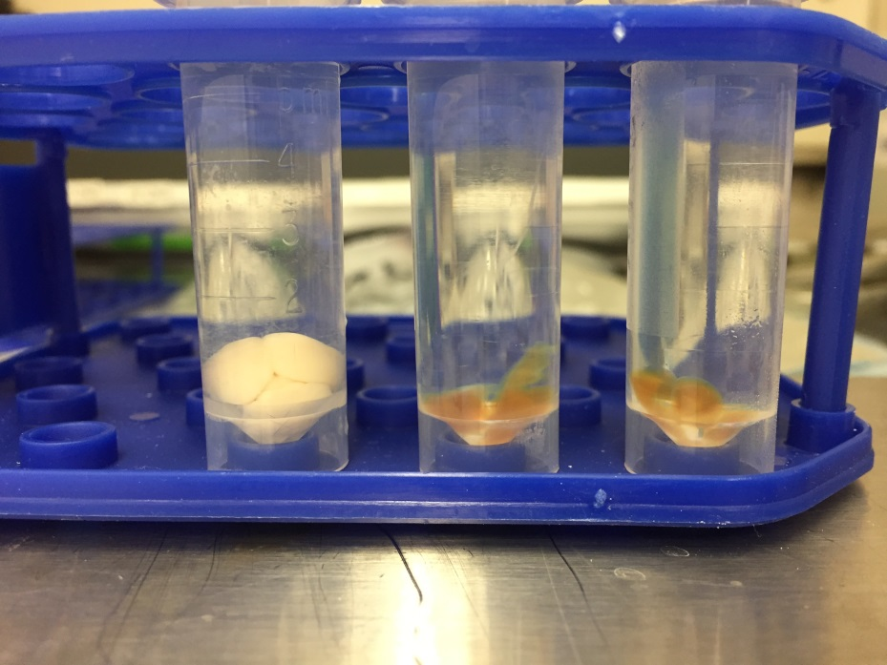

# Troubleshooting

**There is a strong surface background / ring-like background staining.**  
This seems to happen because the primary antibody is too concentrated. Reduce the concentration.

**The samples have an amber color.**  
If the colouring is light, this is normal and will not prevent the imaging. If the amber color is too pronounced, the sample was kept for too long in THF, or it got oxidised because too much air was present in the tube.

# Antibodies tested

## Primaries:

* Tyrosine hydroxylase: 1:100 in 6 mL vial 🡪 60 uL/vial
* Norepinephrine transporter
* dopamine β-hydroxylase
* AT8-human p-tau 🡪 (attempt after successful TH)

## Secondaries:

* Secondary Gt Anti-Rb AlexaFluor 647 (A-21245): 1:100 in 6 mL vial 🡪 60 uL/vial

# Light Sheet Imaging

### Mount to sample holder

Use Krazy glue, not locate cyanoacrylate (ECi dissolves this)

### Schedule LaVision Ultramicroscope at Microscopy Core with Nikos & Sijie

(Korey has the account)

* Verify with 1.3x whole sample
* Then max at 4x once verified

# Quantification

* Learn clearmap (but I’ll most likely need access to the Microscopy Core’s server to run a python script on it):
* <https://rawgit.com/ChristophKirst/ClearMap/master/docs/_build/html/index.html>
* Test on trial dataset first (Reneir’s cFos mouse brain).
* IMARIS

# References

* Klingberg et al., Fully Automated Evaluation of Total Glomerular Number and Capillary Tuft Size in Nephritic Kidneys Using Lightsheet Microscopy, 2017.
* Renier et al., Mapping of Brain Activity by Automated Volume Analysis of Immediate Early Genes, 2016.
* Renier et al., iDISCO: a simple, rapid method to immunolabel large tissue samples for volume imaging, 2014.
* <https://idiscodotinfo.files.wordpress.com/2015/04/whole-mount-staining-bench-protocol-methanol-dec-2016.pdf>